CBCT-Guided Multidisciplinary Management of Heithersay Class III Invasive Cervical Resorption Using Bioceramic Materials and Injectable Composite: A Case Report
Fani Pangabdian1, Diana Soesilo2, Aprilia3, Eddy Hermanto4, Sarianoferni5
1 Department of Dental Conservation, Faculty of Dentistry, Universitas Hang Tuah, Surabaya, Indonesia
2 Department of Dental Conservation, Faculty of Dentistry, Universitas Hang Tuah, Surabaya, Indonesia
3 Department of Dental Conservation, Faculty of Dentistry, Universitas Hang Tuah, Surabaya, Indonesia
4 Department of Oral and Maxillofacial Surgery, Faculty of Dentistry, Universitas Hang Tuah, Surabaya, Indonesia
5 Department of Oral and Maxillofacial Radiology, Faculty of Dentistry, Universitas Hang Tuah, Surabaya, Indonesia
Corresponding author: Fani Pangabdian, Department of Dental Conservation, Faculty of Dentistry, Universitas Hang Tuah, Jl. Arief Rachman Hakim No. 150, Surabaya 60111, Indonesia. Email: fani.pangabdian@hangtuah.ac.id. Phone: +62 817 386 917.

Abstract
Invasive cervical resorption (ICR) is a progressive form of external root resorption that may remain asymptomatic until extensive cervical and radicular tooth destruction has occurred. Accurate three-dimensional assessment is essential for determining the extent of the lesion and selecting an appropriate treatment strategy. This case report describes the cone-beam computed tomography (CBCT)-guided multidisciplinary management of a Heithersay Class III ICR lesion with subcrestal involvement in a 35-year-old female patient with a history of dental trauma and previous fixed orthodontic treatment. Clinical examination revealed cervical discoloration, bleeding on probing, and a non-vital maxillary left central incisor. Periapical radiography and CBCT confirmed an invasive cervical resorptive defect extending into the coronal third of the root with thinning of the buccal cortical plate. Management included nonsurgical root canal treatment using gutta-percha and a bioceramic sealer, followed by surgical flap access, debridement of granulation tissue, defect repair with mineral trioxide aggregate (MTA), and esthetic restoration using injectable composite. At the six-month follow-up, the tooth remained asymptomatic, with healthy periodontal tissues and no radiographic evidence of periapical pathology or further resorptive progression. This case highlights the clinical value of CBCT-based diagnosis, interdisciplinary treatment planning, and the combined use of bioactive materials and esthetic restorative techniques in preserving teeth affected by advanced ICR.
Categories: Dentistry, Oral Medicine, Radiology
Keywords: invasive cervical resorption, external cervical resorption, cone-beam computed tomography, mineral trioxide aggregate, bioceramic sealer, injectable composite, endodontic therapy

Introduction
Root resorption is a pathological condition characterized by progressive loss of dental hard tissues, particularly affecting the root structure, and may ultimately lead to tooth loss if left untreated [1]. It is broadly classified into internal and external resorption. Internal resorption originates within the pulp chamber and progresses outward, whereas external resorption initiates from the external root surface and may extend toward the pulp space [2].
Invasive cervical resorption (ICR) represents a distinct subtype of external resorption that originates at the cervical region of the tooth, typically near the cemento-enamel junction. This condition is characterized by its progressive and destructive behavior. In its early stages, ICR is frequently asymptomatic and may be misinterpreted as cervical caries, leading to delayed diagnosis [1,3].
The term ICR was introduced and popularized by Heithersay, who proposed a classification system based on lesion severity. This classification includes four categories: Class I, a small superficial lesion; Class II, a well-defined lesion approaching the pulp; Class III, a deeper lesion extending into the coronal third of the root; and Class IV, an extensive lesion extending beyond the coronal third of the root [4,5].
The etiology of ICR is considered multifactorial. Commonly associated predisposing factors include dental trauma, orthodontic treatment, internal bleaching procedures, periodontal surgical interventions, deep cervical restorations, and previous endodontic treatment [6]. Despite these associations, the exact pathogenesis of ICR remains incompletely understood, and further research is required to clarify the underlying biological mechanisms.
Clinically, ICR often presents without symptoms. In some cases, however, a characteristic pinkish discoloration, commonly described as a "pink spot," may be observed, along with bleeding on probing. In the early phase, the pulp may remain vital; therefore, vitality testing is important in differentiating ICR from cervical caries, internal resorption, cervical root fracture, and combined endodontic-periodontal lesions [7].
Radiographically, ICR may appear as an irregular radiolucency in the cervical region with poorly defined margins. A key feature that helps distinguish it from internal resorption is the preservation of the root canal outline. CBCT imaging is strongly recommended to improve diagnostic accuracy because it provides three-dimensional assessment of lesion extent, proximity to the pulp space, and involvement of surrounding structures, thereby supporting more precise treatment planning [4,8].
Although several approaches for the management of ICR have been reported, clinical decision-making remains challenging when the lesion extends subcrestally and involves both endodontic and periodontal-restorative considerations. The present case is clinically relevant because it demonstrates a multidisciplinary, CBCT-guided treatment strategy for a Heithersay Class III ICR lesion using endodontic therapy, surgical debridement, MTA repair, and injectable composite restoration to preserve function and esthetics.

Case Presentation
A 35-year-old female patient presented to RSGM Nala Husada with a chief complaint of reddish swelling in the maxillary left anterior gingival region. The patient reported a history of dental trauma four years earlier, followed by fixed orthodontic treatment. Initially, she experienced pain; however, the symptoms gradually subsided over time.
Clinical examination revealed discoloration on the labial cervical surface of tooth 21. Probing detected a catch in the cervical area accompanied by bleeding. Percussion and palpation tests were positive, and pulp vitality testing indicated that the tooth was non-vital (Figure 1).
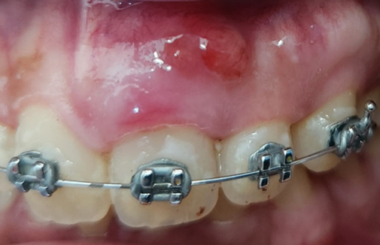
Figure 1. Preoperative clinical photograph showing cervical discoloration and gingival involvement of tooth 21.
Radiographic examination demonstrated an irregular radiolucent area with a mottled appearance. The lesion involved enamel and dentin, extended close to the pulp space, and spread into the coronal one-third of the root. Based on the two-dimensional Heithersay classification system, the lesion was categorized as Class III because it showed deep dentin invasion extending into the coronal third of the root. CBCT analysis provided more detailed visualization, revealing a radiolucent defect invading enamel and dentin, approaching the pulp space, and associated with thinning of the buccal cortical plate (Figure 2).

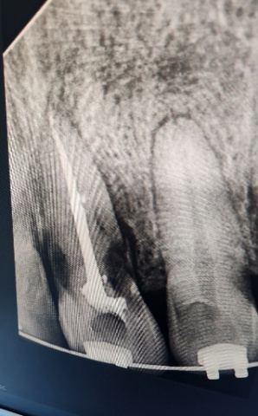 | 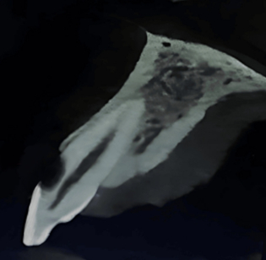 | 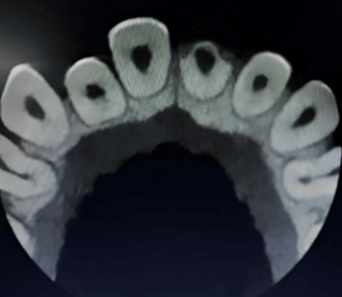
Figure 2. Preoperative radiographic and CBCT evaluation of tooth 21. (A) Periapical radiograph showing an irregular radiolucent lesion in the cervical region extending into the coronal third of the root. (B) Sagittal CBCT section showing the extent of the resorptive defect. (C) Axial CBCT section showing buccal cortical plate thinning and the spatial relationship of the lesion to the root canal.

Treatment
After written informed consent had been obtained, root canal treatment was initiated under rubber dam isolation. Access was prepared through the palatal aspect, followed by working length determination using an apex locator and radiographic confirmation. Biomechanical preparation began with glide path establishment using a #10 K-file, followed by rotary instrumentation up to size F3. The irrigation protocol was performed using 2.5% sodium hypochlorite (NaOCl) and 17% ethylenediaminetetraacetic acid (EDTA) at each instrument change. Calcium hydroxide was applied as an intracanal medicament for 14 days as an additional disinfection step. Subsequently, root canal obturation was performed using gutta-percha and a bioceramic sealer before surgical intervention (Figure 3).
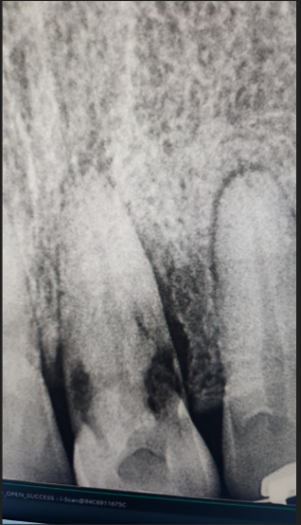
Figure 3. Root canal treatment of tooth 21. Working length determination, biomechanical preparation, irrigation, intracanal medication, and obturation were performed before surgical repair.
At the subsequent visit, a surgical procedure was performed to repair the resorptive defect under local anesthesia. A full-thickness mucoperiosteal flap was raised on the labial side. After flap reflection, granulomatous tissue extending from the labial surface to the cervical third of the crown was observed. The resorptive tissue was carefully curetted until bleeding was controlled. The defect area was then disinfected using 5.25% NaOCl to reach microscopic areas. The defect was repaired using MTA according to the manufacturer's instructions, and the flap was repositioned and sutured (Figure 4).
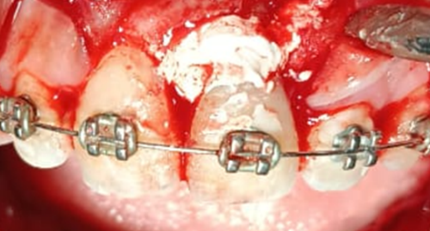 | 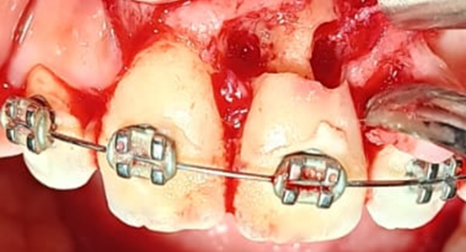
Figure 4. Surgical management of the invasive cervical resorption defect. (A) Full-thickness flap reflection and exposure of the resorptive defect. (B) Defect repair using MTA after debridement of granulation tissue.
After four weeks, the patient was recalled for evaluation of soft tissue healing following the surgical procedure. Restoration of the cervical region was then performed using injectable composite. Six-month follow-up showed favorable healing. Radiographically, there were no periapical abnormalities, and the surrounding bone condition appeared healthy. Clinically, the treated tooth remained asymptomatic, with healthy gingiva and no signs of pathological changes in the periodontal tissues (Figure 5).
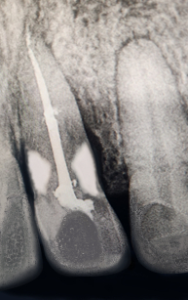 | 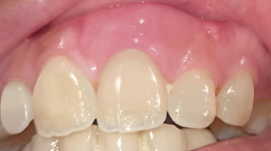
Figure 5. Six-month postoperative follow-up. (A) Radiographic evaluation showing absence of periapical pathology and no evidence of further resorption. (B) Clinical view showing healthy gingival tissues and satisfactory esthetic restoration.

Discussion
The management of ICR is primarily determined by the extent and severity of the lesion. The fundamental objective is to arrest the resorptive process through complete removal of resorptive tissue, followed by restoration of the defect using biocompatible materials [1,8]. In the present case, the lesion was classified as Heithersay Class III, indicating substantial structural involvement. Therefore, a combined approach involving endodontic therapy and surgical access was necessary to adequately manage the subgingival component of the defect.
The pathogenesis of ICR is thought to begin with damage to the cervical cementum, resulting in exposure of the underlying dentin. This exposure may facilitate the infiltration of clastic cells, including osteoclasts and odontoclasts, derived from periodontal tissues [5,6]. In addition, proliferation of granulation tissue has been proposed as a contributing factor, allowing the lesion to expand laterally and apically within dentin [7]. The patient in this report had a history of dental trauma and fixed orthodontic treatment, both of which are recognized predisposing factors for ICR [6].
Diagnosis of ICR can be challenging because clinical signs may be subtle and conventional periapical radiographs may underestimate the true extent of the lesion. While two-dimensional radiography suggested a cervical resorptive defect, CBCT was essential for confirming the depth, circumferential extension, proximity to the pulp space, and thinning of the buccal cortical plate. This information guided the decision to combine nonsurgical root canal treatment with surgical debridement and restorative repair, rather than relying on an internal or purely restorative approach.
A multidisciplinary approach was required because the lesion involved multiple clinical domains: endodontic infection control, surgical access for complete debridement, radiologic assessment of lesion extension, and restorative rehabilitation of the cervical defect. Endodontic treatment was performed before surgical repair because the tooth was non-vital and the lesion approached the pulp space. Surgical access then allowed direct visualization and removal of granulation tissue, which is critical for arresting the resorptive process and reducing the risk of recurrence.
MTA was selected for defect repair because of its biocompatibility, sealing capacity, and suitability for irregular defects in close proximity to periodontal tissues [3,4,8]. Its bioactive properties may support hard tissue repair and periodontal healing when used in cervical resorptive defects. In addition, the use of a bioceramic sealer in conjunction with gutta-percha contributed to the endodontic seal and supported the overall biological approach to treatment.
The subsequent use of injectable composite was intended to restore the cervical contour, improve esthetics, and support marginal adaptation in an anatomically challenging area. This combined approach allowed biological repair of the resorptive defect and esthetic rehabilitation of the coronal structure. At the six-month follow-up, the absence of symptoms, healthy periodontal tissues, and lack of radiographic pathology suggested a favorable short-term outcome.
This report has several limitations. First, it describes a single case; therefore, the outcome cannot be generalized to all Heithersay Class III ICR lesions. Second, the follow-up period was limited to six months, whereas ICR requires long-term monitoring because recurrence or periodontal changes may occur over time. Third, although clinical and radiographic healing was observed, future evaluation with longer follow-up and, when indicated, CBCT reassessment would provide stronger evidence regarding treatment stability.

Conclusions
CBCT-guided diagnosis and treatment planning are essential in the management of invasive cervical resorption, particularly when the lesion extends subcrestally and involves the coronal third of the root. In this case, a multidisciplinary approach combining root canal treatment, surgical debridement, MTA repair, and injectable composite restoration resulted in favorable clinical and radiographic outcomes at six months. The case emphasizes that preservation of teeth affected by Heithersay Class III ICR is possible when accurate three-dimensional diagnosis, complete debridement, bioactive repair materials, and esthetic restorative procedures are integrated into a single treatment strategy. Long-term follow-up remains necessary to monitor periodontal stability and detect possible recurrence.

Additional Information

Disclosures
Human subjects: Written informed consent was obtained from the patient for treatment, publication of this case report, and the use of anonymized clinical and radiographic images.
Conflicts of interest: In compliance with the ICMJE uniform disclosure form, all authors declare that they have no conflicts of interest.
Payment/services information: All authors declare that no financial support was received from any organization for the submitted work.
Financial relationships: All authors declare that they have no financial relationships at present or within the previous three years with any organizations that might have an interest in the submitted work.
Other relationships: All authors declare that there are no other relationships or activities that could appear to have influenced the submitted work.

Author Contributions
All authors reviewed and approved the final version of the manuscript and agreed to be accountable for all aspects of the work.
Contribution role | Authors
Concept and design | Fani Pangabdian, Diana Soesilo, Aprilia
Acquisition, analysis, or interpretation of data | Fani Pangabdian, Eddy Hermanto, Sarianoferni
Drafting of the manuscript | Fani Pangabdian, Aprilia
Critical review of the manuscript for important intellectual content | Diana Soesilo, Eddy Hermanto, Sarianoferni
Supervision | Diana Soesilo, Eddy Hermanto, Sarianoferni

Acknowledgements
The authors would like to thank Universitas Hang Tuah and RSGM Nala Husada for supporting the clinical management and documentation of this case report.

References
1. Nireeksha BN, Harsha P, Naik BD, Setty S, Horatti P. Management of invasive external cervical resorption in maxillary anterior teeth: a case report. J Restor Dent Endod. 2022;1:63-66. doi:10.25259/jrde_2_2022
2. Garg N, Garg A. Textbook of Endodontics. 4th ed. New Delhi: Jaypee Brothers Medical Publisher (P) Ltd; 2022.
3. da Cunha Isaltino M, da Silva Souza C, de Oliveira NG, de Melo Júnior PM, Velozo Telles CT, de Albuquerque DS. Endodontic and surgical management of an invasive cervical resorption in a maxillary central incisor: a case report. Iran Endod J. 2023;18:168-173. doi:10.22037/iej.v18i3.41385
4. Ghabraei S, Bolhari B, Hashemi N, Gharehchahi H. Conservative management of an advanced external cervical resorption with internal approach using bio-ceramic materials: a case report. Clin Case Rep. 2024;12:e8378. doi:10.1002/ccr3.8378
5. Howait M, Shaker M, Aljuhani H, AlMohnna M. External cervical resorption: a case report and brief review of the literature, and treatment algorithms. J Contemp Dent Pract. 2021;22:298-303. doi:10.5005/jp-journals-10024-3013
6. Chen Y, Huang Y, Deng X. External cervical resorption: a review of pathogenesis and potential predisposing factors. Int J Oral Sci. 2021;13:19. doi:10.1038/s41368-021-00121-9
7. Lin Y, Thumbigere-Math V, Kishen A, He J. Unraveling the etiology and pathogenesis of multiple cervical root resorption: a scoping review. J Endod. 2025. doi:10.1016/j.joen.2025.02.012
8. Bardini G, Orrù C, Ideo F, Nagendrababu V, Dummer PMH, Cotti E. Clinical management of external cervical resorption: a systematic review. Aust Endod J. 2023;49:769-787. doi:10.1111/aej.12794
9. Mount GJ, Hume WR, Ngo HC, Wolff MS, eds. Preservation and Restoration of Tooth Structure. 3rd ed. New York: John Wiley & Sons; 2016.
10. Ritter AV, Boushell LW, Walter R. Sturdevant's Art and Science of Operative Dentistry. 7th ed. St. Louis: Elsevier; 2019.
11. Torabinejad M, Fouad AF, Shabahang S. Endodontics: Principles and Practice. 6th ed. St. Louis: Elsevier; 2021.
12. Stefanac SJ, Nesbit SP. Diagnosis and Treatment Planning in Dentistry. 3rd ed. St. Louis: Elsevier; 2017.

